

**NFC-IET MULTAN**

**BSSE-2K24**

**Lab Report**

**ICT (Information & Communication**

**Technology Fundamental)**

**Submitted by:** Muhammad Hassan.

**Roll #:** 2K24-BSSE-247.

**Section:** B.

**Submitted to:** Ma’am Fabiha Alam.

**LAB # 1**

* **Typing Practices (Typing tutor):**

**Note on Typing Practices (Typing Tutor)**

Typing practices are essential for improving one's speed and accuracy when using a keyboard. Typing tutors or typing software are designed to assist individuals in learning how to type more effectively, whether they are beginners or advanced users looking to refine their skills. Below is a detailed exploration of typing practices, focusing on how typing tutors can aid in this development.

**1. Introduction to Typing Practices**

Typing practices involve exercises and methods designed to help people master typing skills. These skills are crucial in the modern world as they are integral to almost every profession and personal task. Whether for data entry, programming, or just casual browsing, being proficient at typing can save time, improve productivity, and reduce physical strain.

**2. Components of Typing Practices**

Typing practices generally focus on the following aspects:

* **Speed**: The number of words typed per minute (WPM). A higher WPM indicates quicker typing skills.
* **Accuracy**: The percentage of correct keystrokes without errors. Accuracy is often prioritized over speed in the early stages of learning.
* **Posture**: Proper hand and finger placement on the keyboard, along with a correct sitting posture, is essential for reducing strain and preventing repetitive stress injuries like carpal tunnel syndrome.
* **Touch Typing**: The ability to type without looking at the keyboard, relying on muscle memory and familiarity with the position of the keys.

**3. Role of Typing Tutors in Typing Practices**

Typing tutors are software applications or online platforms designed to teach and improve typing skills. They provide structured lessons and exercises that gradually build speed and accuracy. Key features of typing tutors include:

* **Guided Lessons**: Typing tutors typically start with basic exercises, such as learning the home row keys (ASDF, JKL;), then move on to more complex exercises that incorporate numbers, symbols, and punctuation. Lessons are often broken into small sections, allowing learners to progress at their own pace.
* **Real-Time Feedback**: One of the key benefits of typing tutors is the immediate feedback provided. When a user makes a mistake, the tutor can highlight the error, tell the user the specific mistake, and provide tips for improvement. This instant feedback helps learners correct bad habits early on and stay motivated.
* **Progress Tracking**: Many typing programs track the user’s progress over time. This could include measuring typing speed, accuracy, and improvement over specific lessons or time frames. Progress tracking also allows users to set goals, such as reaching a specific words-per-minute target.
* **Timed Tests**: To help users gauge their typing speed and accuracy, most typing tutors feature timed tests. These tests typically give a set period (e.g., 1 minute or 5 minutes) to type a passage or series of words. The results are then given in WPM and accuracy percentage.
* **Variety of Exercises**: Typing tutors often include different types of exercises, such as:
  + **Text passages**: These may include sentences or paragraphs designed to mimic real-world typing scenarios.
  + **Typing games**: These can make learning fun by combining typing practice with interactive and engaging activities.
  + **Keyboard drills**: These exercises help learners focus on specific keys or key combinations, gradually improving their dexterity and familiarity with the keyboard layout.

**4. Popular Typing Tutor Tools**

Some widely recognized typing tutors include:

* **TypingClub**: A free, web-based tool offering structured lessons, typing games, and progress tracking.
* **KeyBlaze**: A downloadable software offering lessons, typing tests, and games. It is suitable for both beginners and advanced users.
* **Ratatype**: This tool offers an interactive learning experience, with features that allow you to practice typing in different languages.
* **Mavis Beacon Teaches Typing**: One of the longest-standing typing tutor programs, Mavis Beacon provides both lessons and games designed to improve typing skills.
* **10FastFingers**: A simple online typing test website that measures typing speed and accuracy, allowing users to compete against others or track their progress over time.

**5. Benefits of Typing Practice with a Typing Tutor**

Using a typing tutor for consistent typing practice offers several advantages:

* **Improved Efficiency**: As typing speed increases, so does productivity. Individuals can complete tasks like writing emails, creating documents, and even programming more quickly.
* **Increased Accuracy**: Regular practice leads to fewer mistakes, improving the quality of written work.
* **Reduced Physical Strain**: With proper typing techniques (such as touch typing and ergonomic posture), users can avoid strain and discomfort, making long typing sessions less tiring.
* **Improved Professional Skills**: Typing is a key skill for many careers, including administrative roles, customer support, and technical fields. Typing tutors help individuals build these skills for greater job performance.

**6. Tips for Effective Typing Practice**

While using a typing tutor, it’s important to follow best practices for optimal learning:

* **Start slow**: Focus on accuracy rather than speed when you begin, as it’s easier to increase speed once accuracy is solid.
* **Use correct finger placement**: Ensure your fingers are placed on the home row (ASDF for the left hand, JKL; for the right hand) and avoid looking at the keyboard.
* **Practice regularly**: Consistent practice is key to improving typing skills. Aim for at least 15-30 minutes of practice per day.
* **Take breaks**: Avoid fatigue by taking short breaks every 20-30 minutes to stretch and rest your hands.
* **Set goals**: Set achievable goals for both speed and accuracy. For example, aim to increase your WPM by 5 words per minute every week.

**7. Challenges in Typing Practice**

While typing tutors offer great tools for improvement, learners may face certain challenges:

* **Frustration with Slow Progress**: Typing practice can sometimes feel tedious or slow, especially when starting from scratch. However, it’s important to be patient and trust the process.
* **Bad Habits**: Some learners may develop bad habits, such as looking at the keyboard or using improper finger placement. These habits can be hard to break but are crucial to address early on.
* **Injury Risk**: If proper ergonomics are not followed, excessive typing practice can lead to repetitive strain injuries. It’s vital to maintain a good posture, take breaks, and use ergonomic keyboards or chairs when possible.

**8. Conclusion**

Typing practices, especially when supported by typing tutor programs, are a great way to build essential skills for both personal and professional tasks. Whether you are just starting out or looking to refine your existing skills, consistent practice, coupled with feedback and progress tracking, can lead to faster typing speeds and fewer errors. Over time, good typing habits, such as touch typing and ergonomic practices, can ensure that you type efficiently without physical strain.

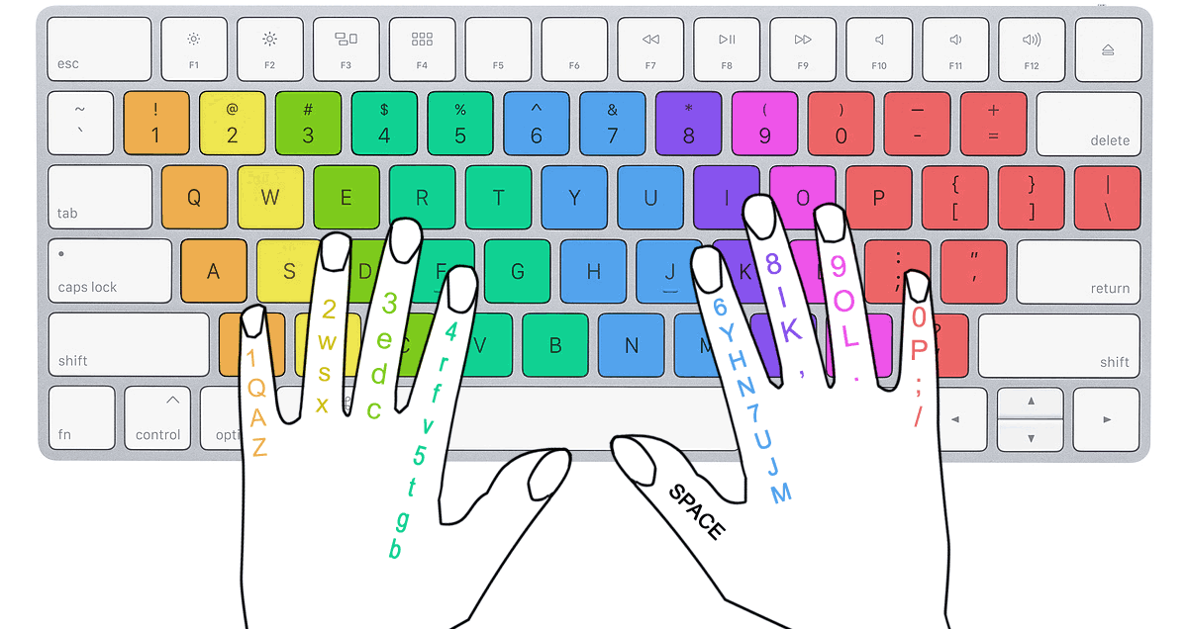

**Proper Finger Placement during TYPING**



* **Internal components of Computer:**

**(Recognition+ understanding)**

The internal components of a computer are the hardware elements housed within the computer case that enable the system to process, store, and execute instructions. These components include:

1. **Central Processing Unit (CPU):**  
   Often referred to as the "brain" of the computer, the CPU performs calculations, executes instructions, and processes data. It consists of cores and threads, which determine its multitasking capabilities.



1. **Motherboard:**  
   The motherboard is the main circuit board that connects all components of the computer. It houses the CPU, RAM, and other essential parts while providing ports and slots for additional hardware.



1. **Random Access Memory (RAM):**  
   RAM is temporary memory that stores data being actively used or processed by the CPU. It ensures quick data access, contributing to the system's overall speed and performance.



1. **Storage Drives:**
   * **Hard Disk Drive (HDD):** Traditional mechanical drives with large storage capacities but slower read/write speeds.
   * **Solid State Drive (SSD):** Faster and more reliable storage that uses flash memory technology.

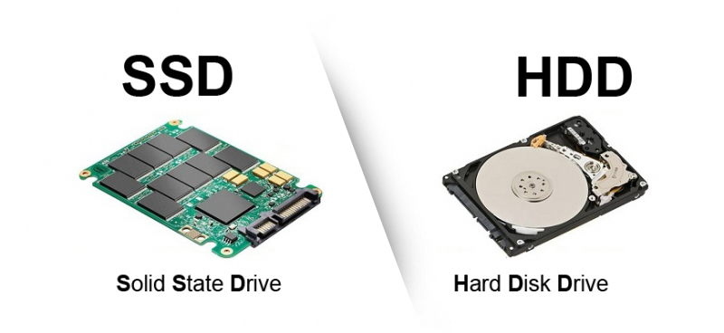

1. **Power Supply Unit (PSU):**  
   The PSU converts electrical power from an outlet into usable power for the computer's components. It distributes energy to the motherboard, CPU, and peripherals.



1. **Graphics Processing Unit (GPU):**  
   Dedicated GPUs handle rendering of images, videos, and 3D graphics, essential for gaming, video editing, and graphical design. Integrated GPUs are built into CPUs for basic visual tasks.



### Summary:

These components work together to ensure the smooth operation of a computer, each playing a critical role in processing, storage, connectivity, and overall functionality.

**LAB # 2**

* **Windows Installation:**

Steps to Install Windows 11:

* **Step 1: Check System Requirements**

1. **Processor:** 1 GHz or faster with at least 2 cores on a compatible 64-bit processor or System on a Chip (SoC).
2. **RAM:** 4 GB or more.
3. **Storage:** 64 GB or larger storage device.
4. **TPM:** Trusted Platform Module (TPM) version 2.0.
5. **Graphics Card:** DirectX 12 compatible graphics / WDDM 2.x.
6. **Display:** >9” with HD Resolution (720p).
7. **Internet Connection:** Internet connectivity is necessary for updates and some features.

* **Step 2: Backup Your Data**

Before proceeding with the installation, back up your important files and data to an external drive or cloud storage to prevent data loss.

* **Step 3: Obtain Windows 11 Installation Media**

1. **Download Windows 11:** Visit the Microsoft Windows 11 download page.
2. **Choose Installation Method:**
   * **Upgrade this PC now:** If you are upgrading from Windows 10.
   * **Create Windows 11 installation media:** If you want to create a bootable USB drive or DVD.

* **Step 4: Create Installation Media (if applicable)**

1. **Run the Media Creation Tool:** Download and run the Media Creation Tool.
2. **Select “Create installation media”:** Choose language, edition, and architecture (64-bit).
3. **Choose USB Flash Drive or ISO file:** Follow the prompts to create the installation media.

* **Step 5: Prepare for Installation**

1. **Insert the Installation Media:** If using a USB drive or DVD, insert it into your PC.
2. **Restart Your PC:** Boot from the installation media by restarting your PC and entering the BIOS/UEFI settings (usually by pressing F2, F12, DEL, or ESC during startup).
3. **Set Boot Order:** Ensure your PC boots from the USB drive or DVD first.

* **Step 6: Start the Installation**

1. **Select Language and Preferences:** When prompted, choose your language, time, and keyboard preferences.
2. **Click “Install Now.”**

* **Step 7: Enter Product Key**

1. **Enter Windows 11 Product Key:** If prompted, enter your product key. If you are upgrading from Windows 10, you can select “I don’t have a product key” to proceed.

* **Step 8: Choose Installation Type**

1. **Upgrade or Custom Installation:**
   * **Upgrade:** Keeps your files and applications.
   * **Custom:** For a fresh installation, select the partition where you want to install Windows 11.

* **Step 9: Format the Partition (if necessary)**

1. **Select the Partition:** If doing a custom install, select the partition and click “Format” if you want to erase everything on it.

* **Step 10: Install Windows 11**

1. **Follow the Prompts:** Windows will copy files, install features, and apply updates. This may take some time.
2. **Restart Your PC:** Your PC will restart several times during the installation process.

* **Step 11: Configure Windows 11**

1. **Personalize Your Settings:** Choose your region, keyboard layout, and other preferences.
2. **Sign in with Microsoft Account:** You can sign in with an existing Microsoft account or create a new one.
3. **Set Up Privacy Settings:** Choose your privacy preferences and settings.

* **Step 12: Complete the Setup**

1. **Finish Installation:** Once all settings are configured, Windows 11 will finish setting up.
2. **Update Windows:** After installation, check for updates in Settings > Windows Update.

* **Step 13: Restore Your Data**

1. **Transfer Files Back:** If you backed up your data, restore it to your new Windows 11 installation.



* **CPU Assembling:**

**CPU Assembling** is the process of installing a Central Processing Unit (CPU) onto a computer's motherboard. This process is a crucial step in building or upgrading a computer. Here’s an overview of the key steps and considerations:

#### **Steps in CPU Assembling**:

1. **Prepare Your Workspace**:
   * Work in a static-free environment to avoid damaging sensitive components.
   * Use an anti-static wrist strap if possible.
   * Ensure you have all necessary tools, such as a screwdriver, thermal paste (if not pre-applied), and the CPU.
2. **Install the CPU**:
   * Locate the CPU socket on the motherboard.
   * Open the CPU socket lever or cover.
   * Align the CPU correctly:
     + Look for a triangular marker on both the CPU and the socket to align them properly.
   * Gently place the CPU into the socket without applying force.
   * Secure the CPU by lowering the socket lever or locking mechanism.
3. **Apply Thermal Paste**:
   * If the CPU cooler does not have pre-applied thermal paste, apply a small, pea-sized amount in the center of the CPU.
   * Spread it evenly if necessary, but avoid over-application.
4. **Attach the CPU Cooler**:
   * Place the cooler over the CPU, aligning it with the mounting brackets.
   * Secure the cooler using the provided screws or clips.
   * Connect the cooler’s fan cable to the CPU fan header on the motherboard.
5. **Check Your Work**:
   * Ensure the CPU and cooler are securely installed.
   * Double-check connections, including the cooler fan.

#### **Tips and Precautions**:

* Always handle the CPU by its edges to avoid damaging the pins or pads.
* Avoid using excessive thermal paste, as it can spill over and damage other components.
* Refer to the motherboard and CPU manuals for specific instructions, as the installation process may vary depending on the hardware.

Proper CPU assembly is essential for the system's stability and thermal performance. Taking the time to assemble it correctly can prevent overheating and ensure optimal functionality of your computer.



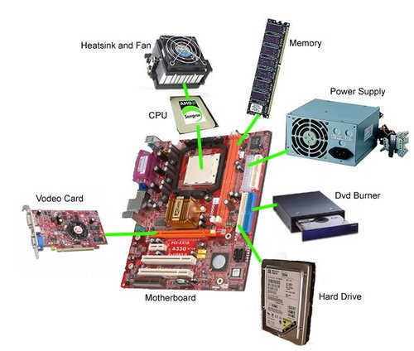

**LAB # 3**

* **Motherboard and it’s Internal Structure:**

The **motherboard** is the primary circuit board of a computer that acts as a backbone, connecting and allowing communication between various components, including the CPU, RAM, storage, and peripherals. It houses essential components and provides ports, slots, and connections to ensure the system's functionality.

#### **Key Components of a Motherboard**:

1. **CPU Socket**:
   * A slot designed to hold and connect the Central Processing Unit (CPU) to the motherboard.
   * Its type (e.g., LGA, PGA, or BGA) depends on the processor.
2. **Chipset**:
   * A set of integrated circuits that manage data flow between the CPU, memory, and peripherals.
   * Includes the **Northbridge** (controls high-speed connections like CPU, RAM, and GPU) and **Southbridge** (manages lower-speed connections like USB, SATA, and audio).
3. **RAM Slots**:
   * Dedicated slots for Random Access Memory (RAM) modules.
   * Typically DDR4 or DDR5, with dual or multi-channel support for improved performance.
4. **Expansion Slots**:
   * PCIe (Peripheral Component Interconnect Express) slots for connecting GPUs, sound cards, network cards, etc.
   * Vary in size, such as x1, x4, x8, or x16 lanes.
5. **Storage Connectors**:
   * SATA ports for connecting SSDs, HDDs, and optical drives.
   * M.2 slots for modern NVMe SSDs, offering high-speed data transfer.
6. **Power Connectors**:
   * ATX power connectors supply power to the motherboard.
   * Includes a 24-pin main power connector and an 8-pin or 4-pin CPU power connector.
7. **BIOS/UEFI Chip**:
   * Non-volatile memory chip that stores the system's firmware.
   * Manages system boot-up and hardware initialization.
8. **Input/Output Ports**:
   * Found on the rear panel, including USB, HDMI, DisplayPort, Ethernet, and audio jacks.
   * Provides connectivity for peripherals like monitors, keyboards, and mice.
9. **Integrated Components**:
   * May include onboard audio chips, network controllers (Ethernet/Wi-Fi), and sometimes GPUs (in the case of integrated graphics).

#### **Internal Structure**:

* **Layers of PCB (Printed Circuit Board)**:
  + Motherboards are multilayered PCBs with conductive pathways (traces) that connect components.
  + Layers are dedicated to power, ground, and signal pathways to minimize interference.
* **Voltage Regulation Modules (VRMs)**:
  + A series of capacitors, inductors, and MOSFETs near the CPU socket.
  + Regulate and supply stable power to the CPU and other components.
* **Heat Management**:
  + Heatsinks and sometimes fans are used to dissipate heat from components like the chipset and VRMs.

#### **Importance of the Motherboard**:

The motherboard determines the compatibility of other components and plays a critical role in the system’s performance and upgrade potential. It acts as the central hub, enabling efficient communication and coordination among hardware components.

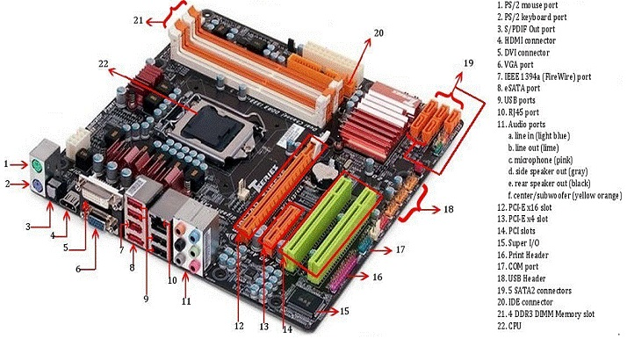

**LAB # 4**

* **Introduction to MS Office:**

**Microsoft Office (MS Office)** is a suite of productivity applications developed by Microsoft, designed to facilitate office-related tasks, communication, and collaboration. It is widely used in businesses, educational institutions, and personal settings due to its versatility and user-friendly interface.

### ****Key Applications in MS Office****:

1. **Microsoft Word**:
   * A word processing application used for creating, editing, and formatting text documents.
   * Features include spell check, templates, mail merge, and advanced formatting tools.
2. **Microsoft Excel**:
   * A spreadsheet application for data analysis, calculations, and visualization.
   * Offers features like formulas, pivot tables, charts, and macros for advanced data manipulation.
3. **Microsoft PowerPoint**:
   * A presentation software used to create and deliver slide-based presentations.
   * Supports text, images, animations, transitions, and multimedia integration.
4. **Microsoft Outlook**:
   * An email client that also provides calendar, task management, and contact organization tools.
   * Integrates with other MS Office applications for seamless communication.
5. **Microsoft Access**:
   * A database management system used for creating and managing databases.
   * Suitable for developing small-scale applications and handling structured data.
6. **Microsoft OneNote**:
   * A digital notebook for note-taking, organization, and collaboration.
   * Allows users to create and share notes that include text, images, and multimedia.
7. **Microsoft Teams**:
   * A communication and collaboration platform.
   * Includes features like chat, video conferencing, file sharing, and integration with other Office apps.

### ****Key Features of MS Office****:

* **Cross-Platform Compatibility**:
  + Available on Windows, macOS, iOS, Android, and web platforms, ensuring accessibility across devices.
* **Integration and Collaboration**:
  + Applications are seamlessly integrated, allowing for real-time collaboration and data sharing.
* **Customization and Templates**:
  + Offers pre-designed templates and customizable options for professional outputs.
* **Cloud Integration (Microsoft 365)**:
  + Enables saving and accessing files via OneDrive, ensuring mobility and data security.

### ****Importance of MS Office****:

* **Enhanced Productivity**:
  + Simplifies tasks like documentation, data management, and presentations.
* **Ease of Use**:
  + Intuitive interface suitable for users of varying skill levels.
* **Global Standard**:
  + Widely adopted, making skills in MS Office essential in many professional environments.

MS Office continues to evolve, incorporating AI-driven features and enhanced collaboration tools to meet the needs of modern users. Whether for personal or professional use, MS Office is a cornerstone of productivity software.

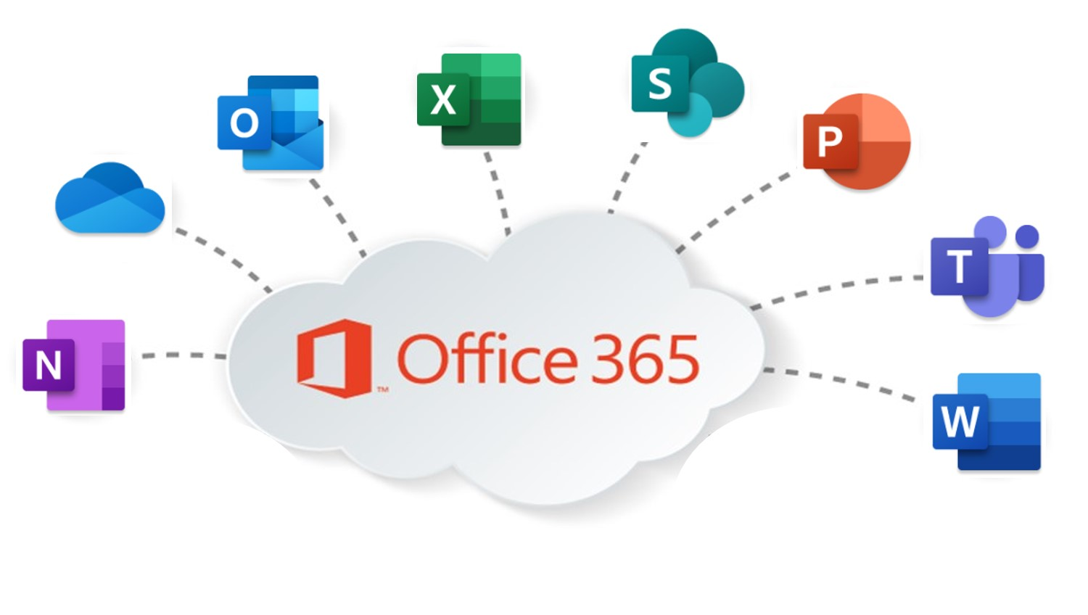

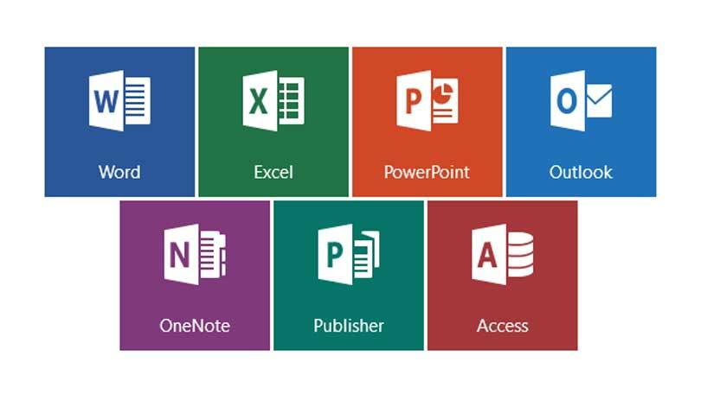

**MS Word basic Features:**

**Microsoft Word (MS Word)** is a widely used word processing application that enables users to create, edit, format, and share text-based documents. It is part of the Microsoft Office suite and offers various features to simplify document creation and enhance productivity.

### ****Basic Features of MS Word****:

1. **Text Editing and Formatting**:
   * Allows users to type, copy, cut, paste, and edit text with ease.
   * Text formatting options include font type, size, color, bold, italic, underline, and strikethrough.
2. **Paragraph Formatting**:
   * Align text (left, right, center, or justify).
   * Adjust line spacing, indentation, and paragraph spacing.
   * Use bullets and numbering for lists.
3. **Page Layout Options**:
   * Set margins, orientation (portrait or landscape), and paper size.
   * Add headers, footers, and page numbers.
   * Apply themes and watermarks to enhance the document's appearance.
4. **Spell Check and Grammar Check**:
   * Built-in tools to identify and correct spelling and grammatical errors.
   * Suggestions for improved clarity and style.
5. **Templates**:
   * Pre-designed templates for resumes, letters, reports, and more.
   * Users can customize templates to suit specific needs.
6. **Tables and Charts**:
   * Insert tables to organize data in rows and columns.
   * Create charts and graphs to visually represent data.
7. **Images and Graphics**:
   * Insert images, shapes, icons, and SmartArt.
   * Customize images with formatting tools like cropping, resizing, and adding effects.
8. **Find and Replace**:
   * Quickly locate specific words or phrases within a document.
   * Replace them with alternatives in one step.
9. **Hyperlinks**:
   * Add clickable links to web pages, email addresses, or other sections within the document.
10. **Reviewing and Collaboration**:
    * Tools for tracking changes, adding comments, and comparing documents.
    * Real-time collaboration with others using Microsoft 365 integration.
11. **File Saving and Export Options**:
    * Save documents in various formats (e.g., .docx, .pdf, .txt).
    * Autosave functionality (with cloud integration like OneDrive) to prevent data loss.
12. **Printing**:
    * Print preview to check the document layout before printing.
    * Options to print specific pages or customize print settings.

### ****Conclusion****:

The intuitive interface and versatile features of MS Word make it a powerful tool for creating professional-quality documents. Whether for personal, academic, or business use, mastering these basic features can significantly improve productivity and document quality.



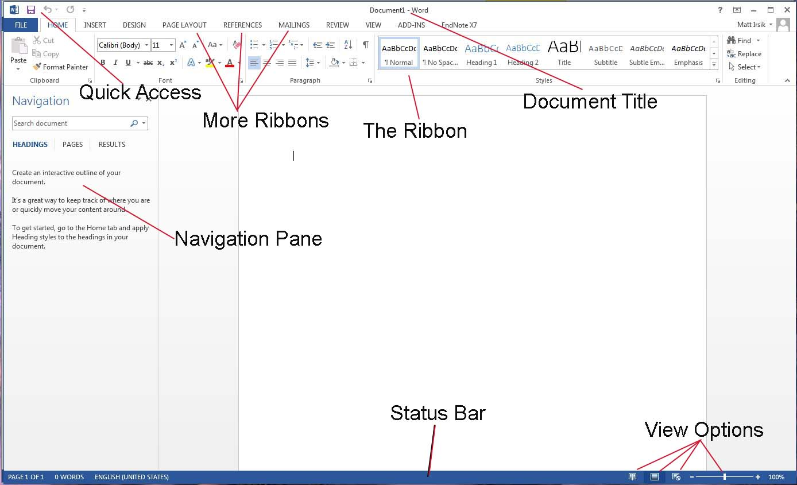

**LAB # 5**

* **MS word Advanced features including mail merge, table of contents, section breaks and references, headers/footers efficiently:**

Microsoft Word offers several advanced features to enhance document creation, formatting, and efficiency, catering to more complex needs like professional documents, academic reports, and automated workflows.

### ****1. Mail Merge****:

* **Purpose**: Automates the creation of personalized documents such as letters, labels, and emails for multiple recipients.
* **How It Works**:
  1. Prepare a main document (e.g., a letter template).
  2. Connect to a data source (e.g., Excel, Access, or Outlook).
  3. Insert merge fields (e.g., name, address) into the template.
  4. Merge the data to generate personalized outputs.
* **Benefits**: Saves time, reduces errors, and is ideal for bulk communication.

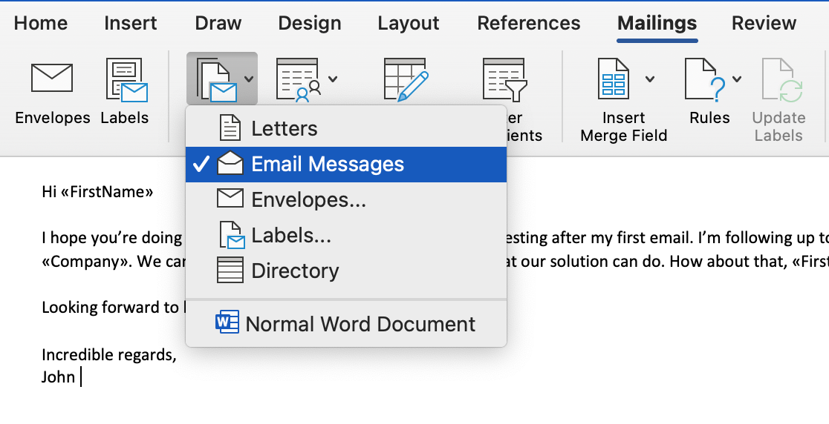

### ****2. Table of Contents (TOC)****:

* **Purpose**: Automatically generates a navigable summary of document headings and subheadings.
* **How to Use**:
  1. Format headings using styles like **Heading 1**, **Heading 2**, etc.
  2. Go to **References** → **Table of Contents** and choose a style.
  3. Update the TOC as needed (e.g., after adding new sections).
* **Benefits**: Helps in organizing long documents, enabling quick navigation and a professional appearance.

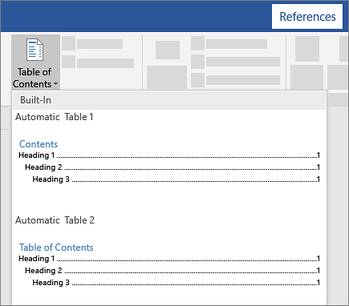

### ****3. Section Breaks****:

* **Purpose**: Divide a document into sections to apply different formatting or layout settings to each.
* **Types of Section Breaks**:
  + **Next Page**: Starts a new section on the next page.
  + **Continuous**: Starts a new section on the same page.
  + **Even/Odd Page**: Starts a new section on the next even or odd page.
* **Applications**:
  + Different headers/footers for sections.
  + Varying page orientations (portrait and landscape) within the same document.
  + Customizing margins, columns, and numbering for specific sections.

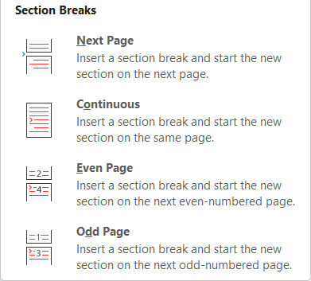

### ****4. References and Citations****:

* **Purpose**: Simplifies academic and research document formatting.
* **Features**:
  + Add citations and sources.
  + Insert a bibliography or works cited section.
  + Use various citation styles like APA, MLA, or Chicago.
* **How to Use**:
  + Go to **References** → **Insert Citation** → **Add New Source**.
  + Select the style and insert citations where needed.
  + Use **Bibliography** to generate a reference list.

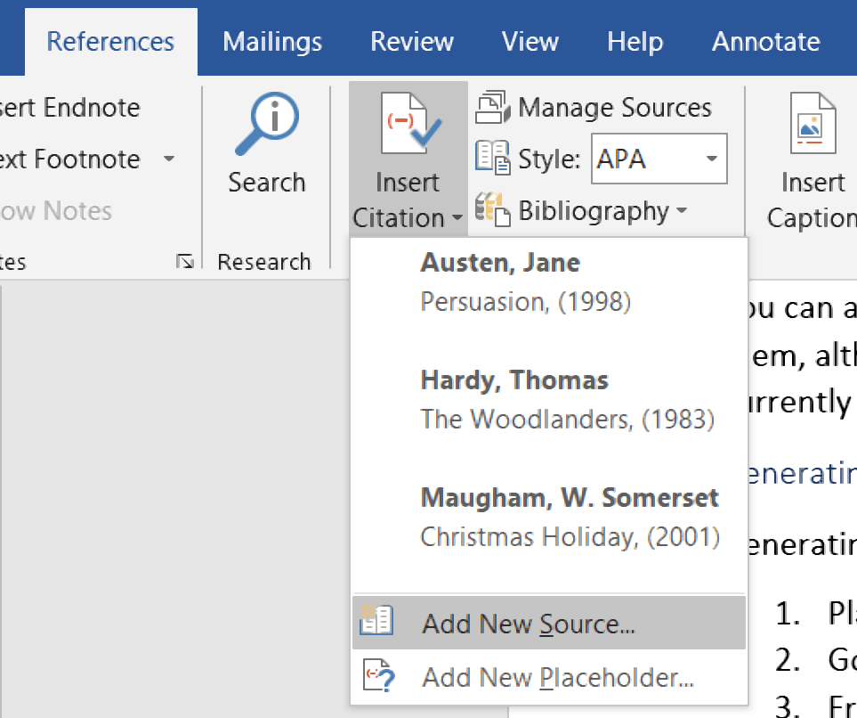

### ****5. Headers and Footers****:

* **Purpose**: Add consistent elements like page numbers, titles, or dates across document pages.
* **Efficient Usage**:
  + Customize headers and footers for different sections using section breaks.
  + Insert dynamic fields like page numbers, file paths, or document properties.
  + Use pre-designed templates or create custom layouts.
* **Tips**:
  + Use the **Link to Previous** option to control continuity between sections.
  + Apply different headers/footers for odd/even pages or the first page.

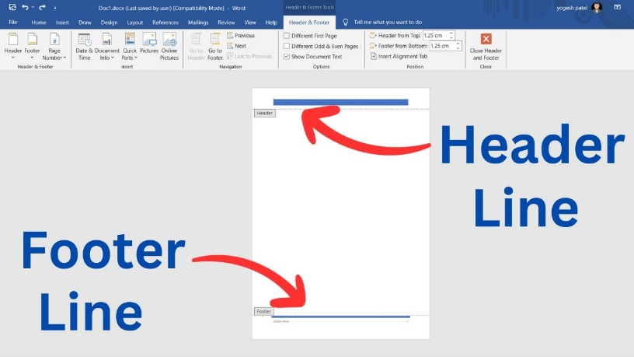

### ****Benefits of These Features****:

* **Time Efficiency**: Automates repetitive tasks like formatting and data entry.
* **Professional Output**: Enhances the document’s structure, readability, and presentation.
* **Versatility**: Adapts to various needs, from business communication to academic research.

By mastering these advanced tools, users can significantly enhance productivity and create polished, well-organized documents.

**LAB # 6**

* **Using Mendeley, Grammarly & PDF Element, Automation with Macros Create and run macros for repetitive tasks, PDF to word conversion, Referencing Tools & Citations, referencing tools for citations, footnotes, and endnotes:**

Modern tools like Mendeley, Grammarly, and PDF Element, combined with automation capabilities like macros and advanced features in Microsoft Word, enhance productivity, accuracy, and document quality.

### ****1. Mendeley: Referencing and Citation Management****

* **Purpose**: A reference manager for organizing and citing research materials.
* **Features**:
  + Import and organize research articles and PDFs.
  + Generate citations in various styles (APA, MLA, Chicago, etc.).
  + Collaborate with peers via shared libraries.
  + Integrates with Word for seamless referencing.
* **Benefits**:
  + Simplifies academic writing by automating citation and bibliography generation.
  + Syncs references across devices.

### ****2. Grammarly: Writing Assistance****

* **Purpose**: An AI-powered writing assistant to enhance grammar, style, and clarity.
* **Features**:
  + Corrects spelling, punctuation, and grammar errors.
  + Offers style and tone suggestions.
  + Detects plagiarism and provides content improvement tips.
* **Benefits**:
  + Ideal for drafting professional documents, academic writing, and business communication.

### ****3. PDF Element: PDF Editing and Conversion****

* **Purpose**: A tool for editing, converting, and managing PDF documents.
* **Features**:
  + Convert PDFs to Word, Excel, or other formats and vice versa.
  + Edit text, images, and annotations within PDFs.
  + Combine, split, and organize PDF pages.
  + Add signatures, watermarks, and secure files.
* **Benefits**:
  + Streamlines workflows involving PDF documents, reducing manual effort.

### ****4. Automation with Macros in Word****

* **Purpose**: Automates repetitive tasks to save time and ensure consistency.
* **How to Use**:
  1. Enable the **Developer** tab in Word.
  2. Go to **Record Macro**, perform the desired actions, and stop recording.
  3. Run the macro by assigning it to a shortcut or menu item.
* **Examples**:
  1. Format text consistently across a document.
  2. Insert repetitive elements like company logos or standard headers.
  3. Automate data entry or table generation.
* **Benefits**:
  1. Reduces errors, increases efficiency, and standardizes outputs.

### ****5. Referencing Tools for Citations, Footnotes, and Endnotes in Word****

* **Citations**:
  + Use the **References** tab to insert citations, manage sources, and generate bibliographies.
  + Choose from various citation styles like APA, MLA, or Harvard.
* **Footnotes and Endnotes**:
  + Insert footnotes or endnotes for additional explanations or references.
  + Use the **References** tab to manage their placement and formatting.
* **Integration**:
  + Tools like Mendeley and EndNote seamlessly integrate with Word for referencing and citation management.
* **Benefits**:
  + Ensures compliance with academic standards and enhances document clarity.

### ****6. PDF to Word Conversion****

* **Purpose**: Converts PDFs to editable Word documents for easier editing and formatting.
* **Tools**:
  + Use PDF Element, Adobe Acrobat, or online tools for conversion.
  + Ensure formatting and content accuracy post-conversion.
* **Benefits**:
  + Makes complex PDF documents editable and reusable.

### ****Conclusion****:

Using tools like Mendeley, Grammarly, and PDF Element, along with Word’s automation capabilities and advanced referencing features, significantly enhances document quality and efficiency. These tools are essential for professionals, academics, and anyone managing complex or large-scale documentation tasks.

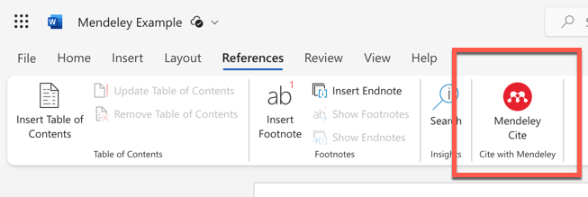

**LAB # 6**

* **Mail managements, Collaborative Tools & Document Protection, (Track changes and comments for collaborative work, Master reviewing and comparing documents, protect documents with passwords and control editing permissions):**

Efficient document handling requires robust tools for managing emails, collaborative editing, and protecting sensitive content. Microsoft Word and related tools provide features that streamline mail management, foster teamwork, and safeguard documents.

### ****1. Mail Management****

Efficient mail management involves organizing correspondence, automating responses, and integrating email systems into workflows. Microsoft Word supports this through tools like **Mail Merge** and integration with email platforms.

#### **Key Features**:

* **Mail Merge**:
  + Automates the creation of personalized emails, letters, and labels.
  + Integrates with data sources like Excel or Outlook.
  + Ideal for bulk communication, such as newsletters and invitations.
* **Integration with Outlook**:
  + Insert email drafts or generate mail-ready attachments directly from Word.
  + Sync calendars and tasks to improve communication efficiency.

#### **Benefits**:

* Saves time and reduces errors.
* Simplifies repetitive email-related tasks.

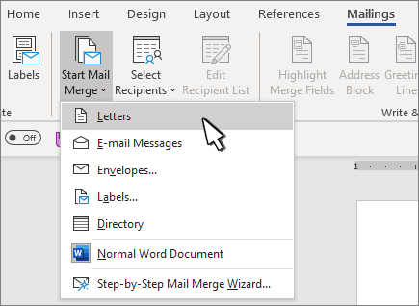

### ****2. Collaborative Tools****

Collaborative work on documents is essential for teams and projects, enabling real-time edits and streamlined feedback.

#### **Track Changes and Comments**:

* **Purpose**: Allows multiple users to suggest edits and add feedback without altering the original text.
* **How to Use**:
  + Enable **Track Changes** from the **Review** tab.
  + Add comments by selecting text and clicking **New Comment**.
  + Accept or reject changes to finalize the document.

#### **Master Reviewing and Comparing Documents**:

* Compare two versions of a document using the **Compare** tool under the **Review** tab.
* Merge revisions from multiple reviewers into a single document.

#### **Real-Time Collaboration**:

* **Microsoft 365 Integration**:
  + Use **Share** to invite others to edit documents in real-time.
  + Co-author documents simultaneously using cloud storage like OneDrive or SharePoint.

#### **Benefits**:

* Enhances teamwork and reduces versioning issues.
* Facilitates efficient feedback loops.

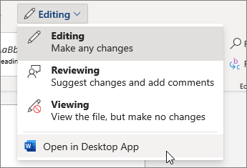

### ****3. Document Protection****

Sensitive documents require measures to ensure confidentiality and control over editing.

#### **Protecting Documents with Passwords**:

* Set a password to restrict access:
  + Go to **File** → **Info** → **Protect Document** → **Encrypt with Password**.
* Allows only authorized users to open the document.

#### **Control Editing Permissions**:

* Restrict editing while allowing others to view:
  + Go to **File** → **Info** → **Protect Document** → **Restrict Editing**.
  + Specify the parts of the document users can edit or set it to read-only.

#### **Digital Signatures**:

* Add a digital signature to authenticate the document:
  + Navigate to **Insert** → **Text** → **Add a Signature Line**.

#### **Benefits**:

* Prevents unauthorized access and tampering.
* Maintains document integrity and confidentiality.

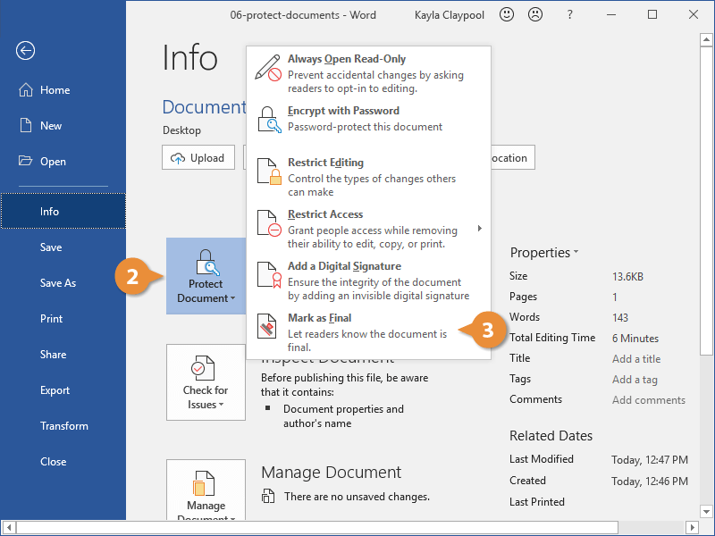

### ****Conclusion****

With features like mail management, collaborative tools, and document protection, Microsoft Word ensures efficient workflows, secure content, and effective teamwork. These capabilities are vital for professional environments, where collaboration and confidentiality are critical.

**LAB # 7**

* **Mail managements, Collaborative Tools & Document Protection,( Track changes and comments for collaborative work, Master reviewing and comparing documents, Protect documents with passwords and control editing permissions)**

Efficient document handling and secure communication are critical in any professional setting. Mastering mail management, collaborative tools, and document protection not only enhances productivity but also ensures the security and integrity of your work. Below, we explore these aspects in detail, covering tools and techniques for optimized workflows and secure collaboration.

#### **1. Mail Management**

Mail management involves organizing and handling email communication to ensure seamless correspondence and follow-ups. Key strategies include:

**a. Organizing Emails Efficiently**

* **Folders and Labels:** Categorize emails into folders (e.g., "Clients," "Projects," "Urgent"). Use color-coded labels for better visibility.
* **Rules and Filters:** Automate email sorting by setting rules based on sender, subject, or keywords.
* **Archiving and Deleting:** Regularly archive important emails for record-keeping and delete unnecessary ones to declutter your inbox.

**b. Prioritization and Response**

* Use tools like **priority markers** or flags to identify emails requiring immediate attention.
* Adopt techniques like **Inbox Zero** to ensure no emails are overlooked.

**c. Integrating Calendar and Task Tools**

* Sync email applications with calendars to schedule meetings or set reminders directly from emails.
* Convert email threads into actionable tasks using tools like Microsoft To-Do or Asana.

#### **2. Collaborative Tools**

Collaborative tools streamline teamwork, making it easier to create, edit, and share documents. They support real-time interaction and ensure transparency in collaborative environments.

**a. Track Changes and Comments for Collaborative Work**

* Tools like **Microsoft Word**, **Google Docs**, or **LibreOffice Writer** allow multiple users to edit documents simultaneously while tracking changes.
* Use **comments** to provide contextual feedback. Highlight specific text or sections and tag collaborators for clarity.

**b. Master Reviewing and Comparing Documents**

* Use document review features like **Compare** (available in Microsoft Word) to identify differences between versions.
* Employ tools like **version history** in cloud platforms such as Google Workspace to review and restore previous versions of a document.
* Ensure a structured reviewing process by assigning clear roles (e.g., reviewer, editor, final approver).

**c. Real-Time Collaboration Tools**  
Platforms like **Slack**, **Microsoft Teams**, and **Notion** integrate messaging with document collaboration, enabling quick discussions and updates. Use **shared whiteboards** and task boards for brainstorming and project management.

#### **3. Document Protection**

Document security is vital to prevent unauthorized access, maintain confidentiality, and safeguard intellectual property. Here’s how to protect documents effectively:

**a. Protect Documents with Passwords**

* Apply strong passwords to sensitive files. In Microsoft Office, use the **File > Info > Protect Document** feature to encrypt documents with a password.
* Ensure passwords are unique, complex, and stored securely using a password manager.

**b. Control Editing Permissions**

* Limit editing access by setting roles such as **view-only, comment-only, or full editing rights** in collaborative tools like Google Drive or OneDrive.
* Use the **Restrict Editing** feature in Microsoft Word to allow only specific types of changes (e.g., filling forms).

**c. Watermarking and Encryption**

* Add watermarks to documents to indicate confidentiality or ownership.
* Use encryption tools for sensitive data, ensuring that only authorized users with the decryption key can access the content.

**d. Regular Backups and Version Control**

* Back up important documents to cloud storage platforms like Dropbox or local servers to prevent data loss.
* Enable **auto-save** features for real-time saving and recovery.

#### **Conclusion**

By implementing efficient mail management, mastering collaborative tools, and securing documents through advanced protection methods, you can achieve a high level of productivity and security in any work environment. These practices not only foster effective collaboration but also ensure that your work remains well-organized and safeguarded against risks.

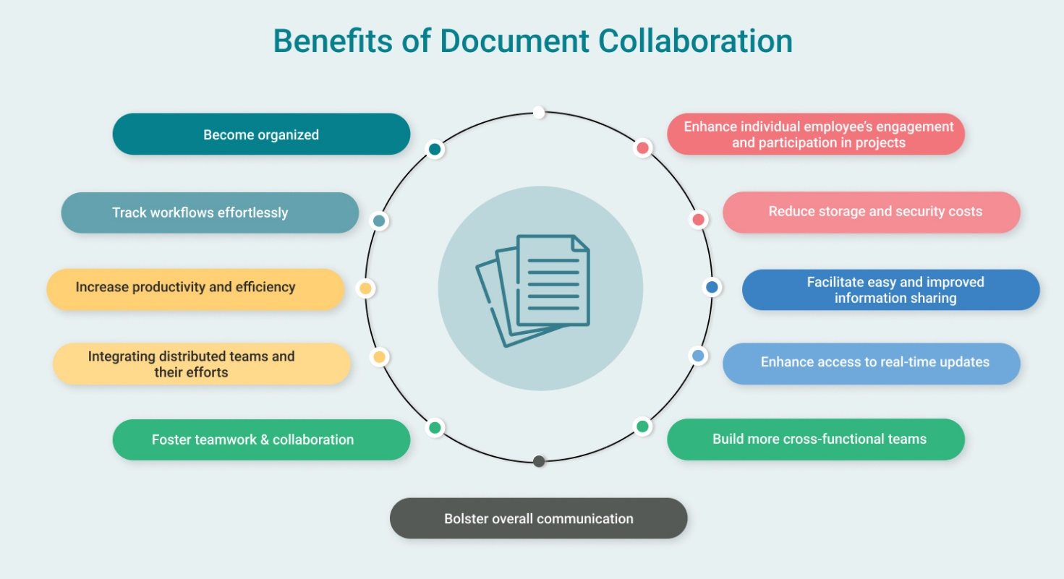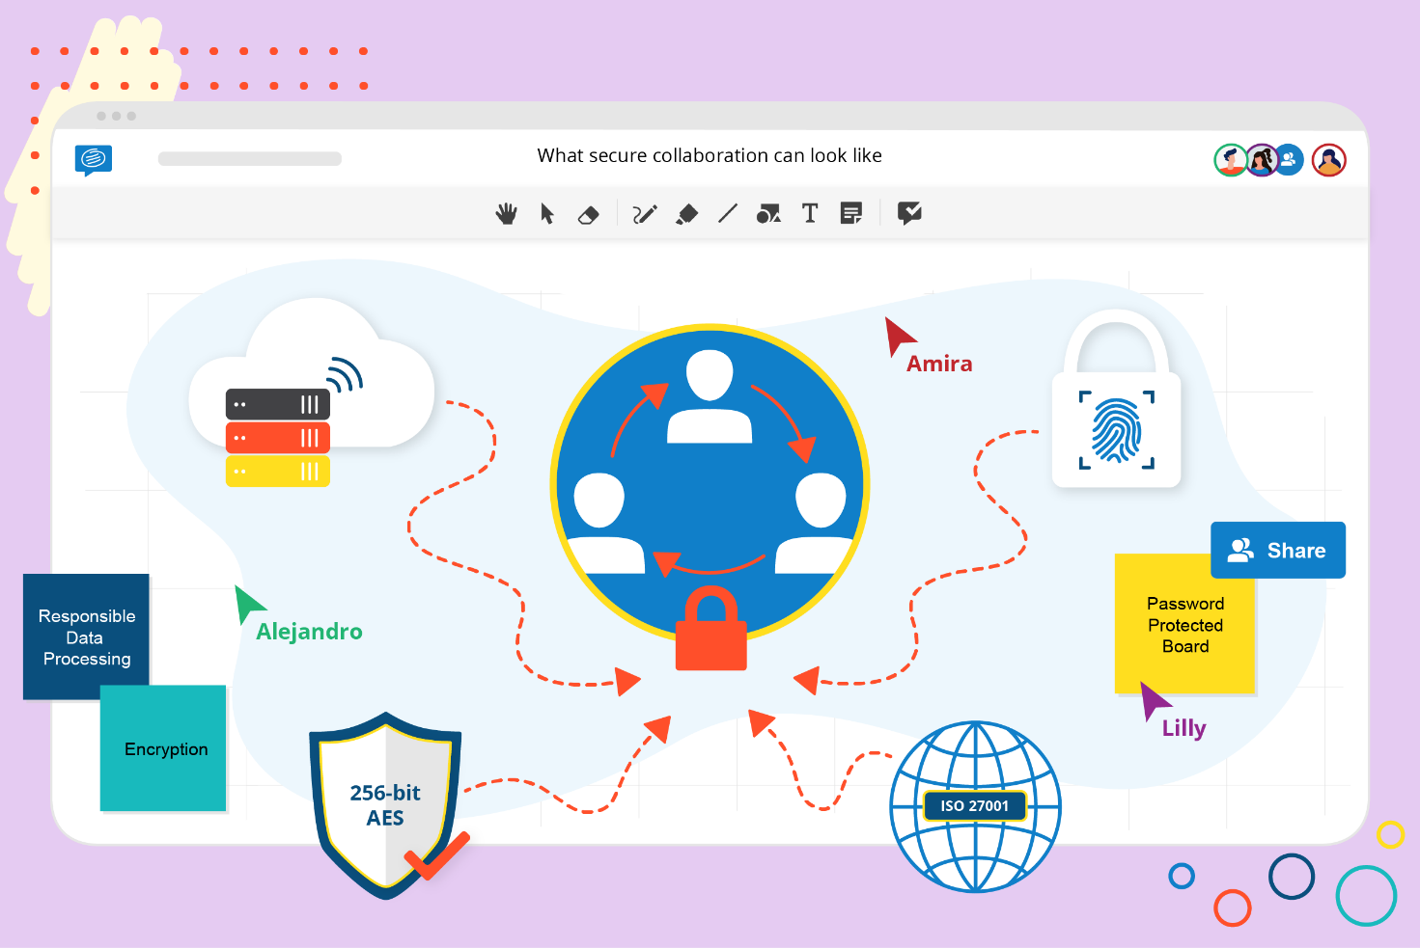

**LAB # 8**

* **Introduction to Excel and Basic Skills, Intermediate Formulas and Functions(Working with Multiple Worksheets ,Using Functions (MIN, MAX, COUNT, IF, etc.)**
* **Introduction to Cell Referencing: Relative, Absolute, and Mixed) Introduction to Sorting and Filtering Data.**

### ****Introduction to Excel and Basic Skills****

Microsoft Excel is one of the most widely used spreadsheet applications, designed for data organization, analysis, and visualization. Whether for personal use or professional tasks, understanding Excel basics provides a strong foundation for productivity and problem-solving.

#### **Basic Skills in Excel**

1. **Navigating the Interface**
   * **Ribbon**: The toolbar at the top with tabs (Home, Insert, Formulas, etc.) containing various commands.
   * **Workbooks and Worksheets**: A workbook is an Excel file containing multiple sheets for data storage and manipulation.
   * **Cells and Ranges**: Cells are individual data points, and ranges are collections of cells identified by their references (e.g., A1:A10).
2. **Entering and Formatting Data**
   * Input numbers, text, or dates into cells.
   * Use formatting tools to change font style, size, color, or cell background.
   * Align text, merge cells, and apply borders for clarity.
3. **Basic Formulas and Functions**
   * Perform calculations using formulas (e.g., =A1+B1).
   * Use basic functions like SUM, AVERAGE, or COUNT to quickly analyze data.
4. **Saving and Printing**
   * Save workbooks in different formats (e.g., .xlsx, .csv).
   * Adjust page layout settings like margins, orientation, and print areas before printing.

### ****Intermediate Formulas and Functions****

Excel’s intermediate features help handle complex calculations, manage data across multiple worksheets, and make logical comparisons.

#### **Working with Multiple Worksheets**

1. **Linking Data Between Sheets**
   * Use formulas to reference data in other sheets:  
     Example: =Sheet2!A1 pulls the value from cell A1 in Sheet2.
   * This is useful for consolidating data from various sheets into a summary sheet.
2. **3D Formulas**
   * Perform calculations across multiple sheets using 3D references:  
     Example: =SUM(Sheet1:Sheet3!A1) adds values from cell A1 in Sheets 1 to 3.

#### **Using Functions (MIN, MAX, COUNT, IF, etc.)**

1. **Statistical Functions**
   * MIN(range): Finds the smallest value.
   * MAX(range): Finds the largest value.
   * COUNT(range): Counts numeric entries in a range.
2. **Logical Functions**
   * IF(logical_test, value_if_true, value_if_false): Performs conditional logic.  
     Example: =IF(A1>50, "Pass", "Fail").
3. **Text Functions**
   * CONCATENATE or TEXTJOIN: Combine text strings.  
     Example: =CONCATENATE(A1, " ", B1) joins first and last names.
   * LEN(cell): Counts characters in a cell.
4. **Lookup Functions**
   * VLOOKUP and HLOOKUP find data in a table based on specific criteria.  
     Example: =VLOOKUP(101, A2:D10, 2, FALSE) looks up the value 101 in the first column and returns data from the second column.

### ****Introduction to Cell Referencing: Relative, Absolute, and Mixed****

Cell referencing is the backbone of formulas in Excel, enabling dynamic updates when cells are copied or moved.

#### **Types of Cell Referencing**

1. **Relative Referencing**
   * Adjusts automatically when copied or filled across cells.  
     Example: In =A1+B1, copying it to another cell will change it to =A2+B2.
2. **Absolute Referencing**
   * Remains fixed regardless of where it is copied.  
     Use $ to lock the reference (e.g., $A$1).  
     Example: =$A$1+B1 always references A1, even when copied.
3. **Mixed Referencing**
   * Combines relative and absolute references.
     + $A1: Column A is fixed, but the row is relative.
     + A$1: Row 1 is fixed, but the column is relative.

#### **Practical Usage**

* **Budget Templates**: Use absolute references for fixed values like tax rates.
* **Dynamic Charts**: Employ relative and mixed referencing for flexible data ranges.

### ****Introduction to Sorting and Filtering Data****

Sorting and filtering are essential for organizing and analyzing data in Excel, making large datasets manageable.

#### **Sorting Data**

1. **Basic Sorting**
   * Sort rows alphabetically, numerically, or by date.  
     Example: Sort a column of names in ascending or descending order.
   * Access sorting options through **Data > Sort**.
2. **Custom Sorting**
   * Sort by multiple levels:  
     Example: First by department, then by employee name.
   * Create custom lists for sorting (e.g., sort days of the week as Monday, Tuesday, etc.).

#### **Filtering Data**

1. **Basic Filtering**
   * Use filters to display specific rows that meet certain criteria.  
     Example: Show only rows where the “Status” column equals “Complete.”
   * Add filters via **Data > Filter** and use drop-down menus.
2. **Advanced Filtering**
   * Filter based on multiple conditions or criteria ranges.  
     Example: Display data where "Sales" are greater than $5000 and "Region" is "North."

#### **Practical Usage**

* **Sales Analysis**: Sort by sales figures to identify top-performing products.
* **Data Cleaning**: Filter out blank or duplicate entries for cleanup.

#### **Project link:**

Hasaan(2K23-BSSE-247).xlsx

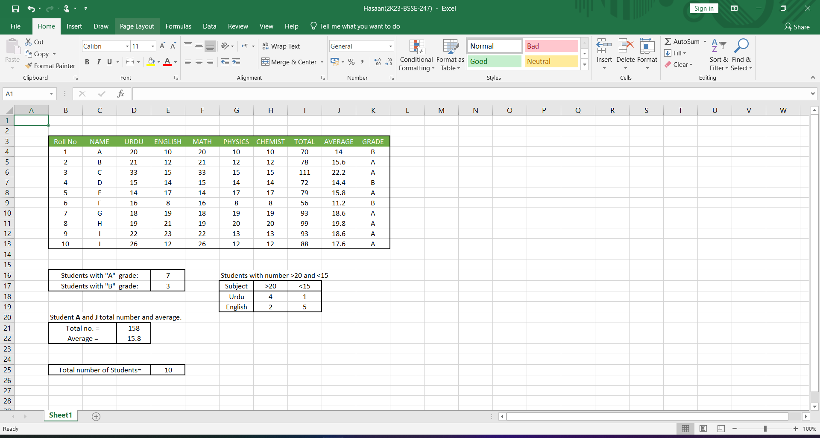

**LAB # 9**

* **Data Visualization and Advanced Features (Creating Charts and Graphs (Bar, Line, Pie),Conditional Formatting,Create Bar code, QR codeWorking with Tables and Data Validation) Also add frequency function and Statistical analysis functions .**

Excel is not just a data entry and calculation tool; it excels at visualizing and analyzing data. Through features like charts, graphs, conditional formatting, and advanced analysis functions, users can transform raw data into meaningful insights.

### ****1. Creating Charts and Graphs****

Visual representation of data is key to better understanding and communication. Excel provides a variety of chart types to suit different data sets and purposes.

#### **Types of Charts and Their Usage**

1. **Bar Chart**
   * Compares data across categories.
   * Example: Visualize sales figures for multiple regions.
2. **Line Chart**
   * Displays trends over time.
   * Example: Track monthly revenue growth or stock prices.
3. **Pie Chart**
   * Shows proportions of a whole.
   * Example: Display the percentage of sales by product category.
4. **Other Charts**
   * **Scatter Plot:** Displays relationships or correlations between variables.
   * **Histogram:** Shows the frequency distribution of data.

#### **Steps to Create a Chart**

1. Highlight the data range.
2. Navigate to **Insert > Charts** and select the desired chart type.
3. Customize the chart using the **Chart Design** and **Format** tabs.

### ****2. Conditional Formatting****

Conditional formatting highlights specific cells or ranges based on criteria, making patterns and trends easily noticeable.

#### **Common Uses of Conditional Formatting**

1. **Data-Based Highlighting**
   * Highlight cells greater than a certain value.
   * Example: Mark sales exceeding $10,000 in green.
2. **Color Scales**
   * Use gradient colors to visualize data magnitude.
   * Example: Apply red-to-green scales for performance levels.
3. **Custom Rules**
   * Use formulas to create dynamic rules.
   * Example: Highlight overdue tasks with =TODAY()>D1.

#### **How to Apply Conditional Formatting**

1. Select the data range.
2. Go to **Home > Conditional Formatting** and choose a rule type.
3. Adjust formatting and conditions as needed.

### ****3. Creating Barcodes and QR Codes****

Excel supports barcode and QR code generation for inventory, labeling, or marketing purposes.

#### **Barcodes**

1. Install a barcode font (e.g., Code 39 or Code 128).
2. Type the barcode data in a cell (e.g., product ID).
3. Apply the barcode font to the cell to generate the barcode.

#### **QR Codes**

1. Use a QR code generator add-in (available in Microsoft Office Add-ins).
2. Input the data to be encoded (e.g., URLs, contact details).
3. Insert the QR code as an image in your worksheet.

### ****4. Working with Tables and Data Validation****

#### **Working with Tables**

Excel tables enhance data organization and provide automatic formatting and filtering capabilities.

1. **Creating a Table**
   * Select your data range and go to **Insert > Table**.
   * Customize table styles and enable the **Total Row** for quick calculations.
2. **Benefits of Tables**
   * Auto-expanding ranges for new data entries.
   * Structured references for formulas (e.g., =SUM(Table1[Sales])).

#### **Data Validation**

Data validation restricts or guides data entry to ensure accuracy.

1. **Common Validation Rules**
   * Allow only numbers, dates, or text.
   * Set value limits (e.g., sales figures between $100 and $10,000).
2. **How to Apply Data Validation**
   * Select the range, go to **Data > Data Validation**, and set criteria.
   * Example: Create a drop-down list of predefined options for a “Region” column.

### ****5. Statistical Analysis Functions****

#### **Frequency Function**

* The **FREQUENCY** function calculates how often values occur in a data range.
* Example: Count scores within predefined intervals.
* Formula: =FREQUENCY(data_array, bins_array)  
  Steps:
  1. Define your data range and intervals (bins).
  2. Use the formula in an array (Ctrl + Shift + Enter for legacy Excel versions).

#### **Statistical Functions**

1. **AVERAGE**: Computes the mean value.
2. **MEDIAN**: Identifies the middle value in a range.
3. **MODE**: Finds the most frequent value.
4. **STDEV**: Calculates standard deviation, indicating data spread.
5. **VAR**: Measures variance, indicating how data points differ from the mean.
6. **CORREL**: Determines the correlation coefficient between two data sets.

### ****Conclusion****

Excel’s advanced features empower users to analyze, visualize, and validate data effectively. From creating professional charts and implementing conditional formatting to generating QR codes and performing statistical analysis, these tools unlock new levels of productivity and insight, making Excel an indispensable tool for data-driven decision-making.

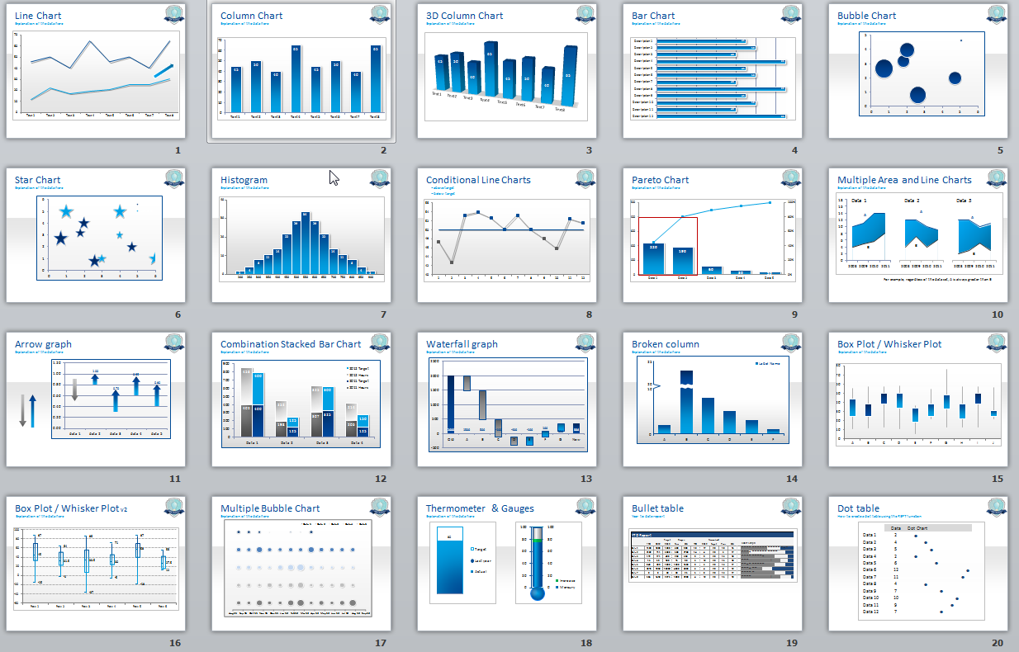

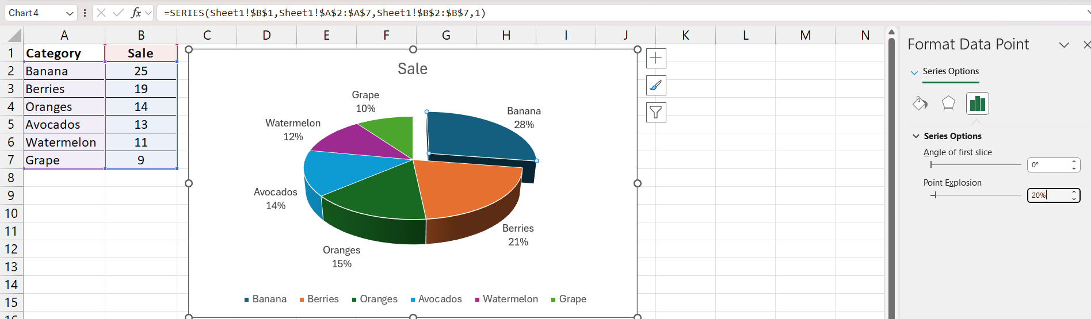

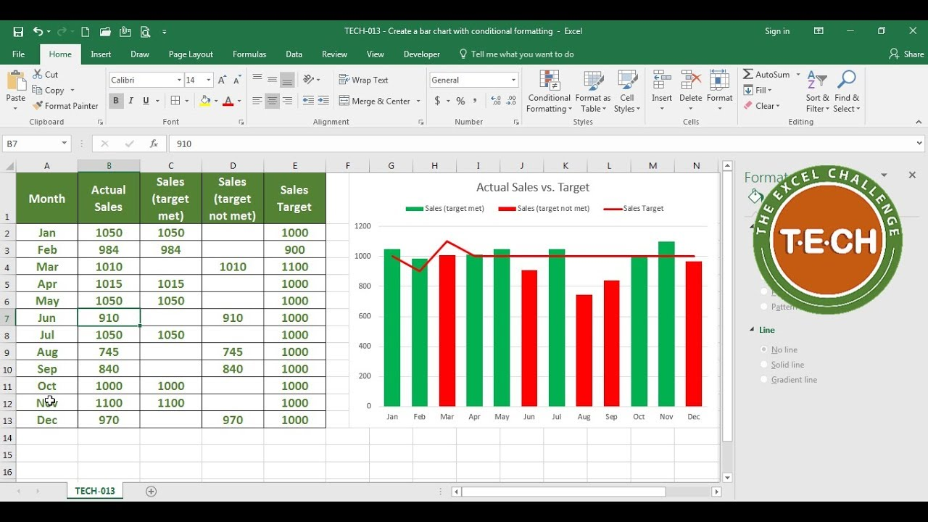

**LAB # 10**

* **Advanced Tools and Final Project (Introduction to Pivot Tables, Using VLOOKUP and HLOOKUP, Introduction to Macros, Final Project: Analyze and Visualize Data Set Using Skills Learned Throughout the Course)**

Excel’s advanced tools, such as Pivot Tables, lookup functions (VLOOKUP and HLOOKUP), and Macros, take data analysis to the next level by offering dynamic ways to manipulate, retrieve, and automate tasks. Mastering these tools sets the foundation for tackling complex projects efficiently. Below is a detailed overview of these advanced tools and their application in a comprehensive final project.

### ****1. Introduction to Pivot Tables****

A Pivot Table is one of the most powerful tools in Excel for summarizing, analyzing, and presenting large data sets. It allows users to dynamically reorganize data to identify trends, patterns, and insights.

#### **Key Features of Pivot Tables**

1. **Data Summarization**
   * Summarize data by categories (e.g., total sales by region).
   * Aggregate data using functions like SUM, AVERAGE, COUNT, MAX, and MIN.
2. **Sorting and Filtering**
   * Easily sort and filter data within the Pivot Table.
   * Example: Filter data to display only sales for specific products or regions.
3. **Grouping**
   * Group data by custom intervals (e.g., grouping dates by months or years).
4. **Creating Calculated Fields**
   * Add custom calculations without altering the original data set.

#### **Steps to Create a Pivot Table**

1. Highlight the data range and go to **Insert > Pivot Table**.
2. Choose whether to create the table in a new worksheet or an existing one.
3. Drag fields to the **Rows**, **Columns**, **Values**, and **Filters** sections in the Pivot Table Field List.
4. Customize the table for desired insights.

#### **Practical Uses**

* Sales analysis by region or product.
* Performance tracking by department or employee.
* Expense categorization and trend analysis.

### ****2. Using VLOOKUP and HLOOKUP****

Lookup functions allow you to retrieve data from a specific column or row in a table, simplifying data retrieval tasks.

#### **VLOOKUP (Vertical Lookup)**

* **Purpose:** Searches for a value in the first column of a table and returns a corresponding value from another column.
* **Syntax:**

excel

Copy code

=VLOOKUP(lookup_value, table_array, col_index_num, [range_lookup])

* Example:
  + Retrieve the price of a product from a product list:  
    =VLOOKUP("Product A", A2:D10, 2, FALSE)

#### **HLOOKUP (Horizontal Lookup)**

* **Purpose:** Searches for a value in the first row of a table and returns a corresponding value from another row.
* **Syntax:**

excel

Copy code

=HLOOKUP(lookup_value, table_array, row_index_num, [range_lookup])

* Example:
  + Find the sales figure for a specific month:  
    =HLOOKUP("January", A1:D3, 2, FALSE)

#### **Common Applications**

* Automating price lists or inventory management.
* Matching data across multiple sheets.
* Creating dynamic dashboards with data updates.

### ****3. Introduction to Macros****

Macros automate repetitive tasks in Excel by recording a sequence of actions and replaying them as needed.

#### **Key Features of Macros**

1. **Recording Actions**
   * Automate tasks such as formatting, calculations, or data entry.
2. **VBA Integration**
   * Advanced users can edit recorded Macros or write custom code in Visual Basic for Applications (VBA).
3. **Assigning Macros**
   * Assign Macros to buttons or keyboard shortcuts for easy execution.

#### **Steps to Record a Macro**

1. Go to **View > Macros > Record Macro**.
2. Name the Macro and assign a shortcut key if needed.
3. Perform the actions to be automated.
4. Stop recording via **View > Macros > Stop Recording**.

#### **Practical Uses of Macros**

* Automating data cleaning processes.
* Generating monthly reports.
* Reformatting large data sets consistently.

### ****4. Final Project: Analyze and Visualize a Data Set Using Skills Learned Throughout the Course****

#### **Objective**

The final project involves applying the skills learned to analyze, summarize, and visualize a data set effectively.

#### **Project Steps**

1. **Choose a Data Set**
   * Example: Sales data for multiple products across regions over several months.
2. **Data Preparation**
   * Clean the data by removing duplicates, handling blanks, and validating entries.
   * Apply **Data Validation** to standardize inputs where necessary.
3. **Analysis and Summarization**
   * Use a **Pivot Table** to summarize total sales by region, product, and time period.
   * Apply **Sorting and Filtering** to focus on specific subsets of data (e.g., top-selling products).
   * Use **Conditional Formatting** to highlight trends (e.g., low-performing regions in red).
4. **Data Retrieval with Lookup Functions**
   * Use **VLOOKUP** to retrieve specific product details.
   * Use **HLOOKUP** to find monthly performance figures.
5. **Data Visualization**
   * Create charts to visualize key insights:
     + **Bar Chart**: Compare regional sales performance.
     + **Line Chart**: Show trends over time.
     + **Pie Chart**: Represent market share by product category.
6. **Advanced Features**
   * Integrate Macros to automate repetitive steps, such as generating the report or formatting charts.
   * Use **Slicers** for interactive filtering in Pivot Tables.
7. **Final Report Presentation**
   * Compile findings into a dashboard or presentation-ready format.
   * Include a mix of charts, tables, and key insights for clarity.

#### **Expected Deliverables**

* A clean and organized workbook.
* Summary insights presented through Pivot Tables and charts.
* Automated processes (if applicable) using Macros.
* A clear explanation of findings with actionable recommendations.

### ****Conclusion****

This advanced toolkit equips you to handle complex data analysis and reporting tasks efficiently. From summarizing data with Pivot Tables to automating workflows using Macros, these skills will enhance your ability to draw insights and make data-driven decisions. The final project serves as a comprehensive application of these tools, showcasing your ability to analyze, visualize, and present data professionally.

